Kendall Joyner

3/31/2024

CTEC 298

LearnPython Tutorials Part 1

**Hello, World**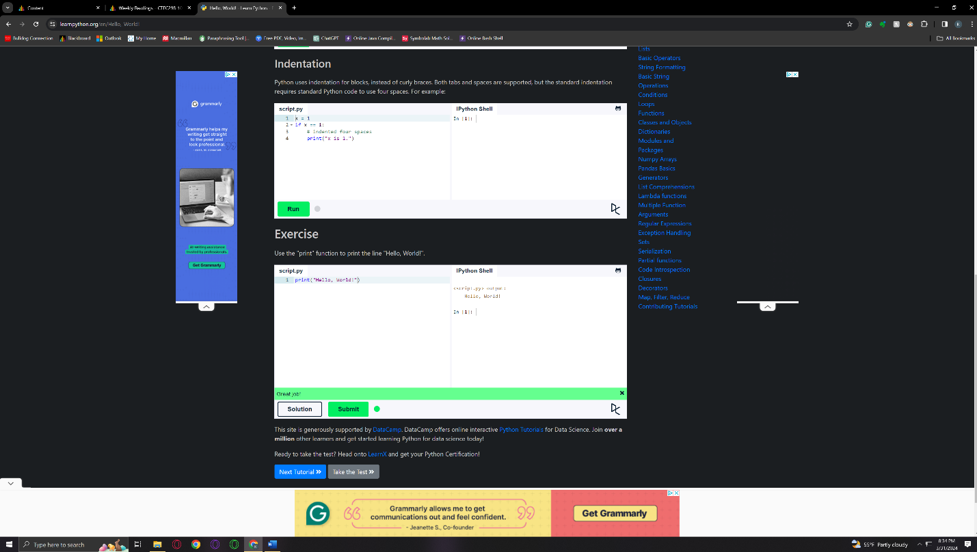

**Lists**

